**Blinkit Analysis**

* See all the data imported:

SELECT * FROM blinkit_data

SELECT DISTINCT Item_Fat_Content FROM blinkit_data;

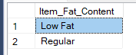

**A. KPI’s**

**1. TOTAL SALES:**

select round(sum(`Total Sales`)/1000000,3)

as Sum_Sales_million

from blinkit_data ;

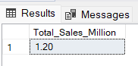

**2. AVERAGE SALES**

select round(avg(`Total Sales`),3)

as avg_Sales_million

from blinkit_data ;

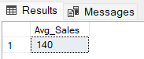

**3. NO OF ITEMS**

SELECT COUNT(*) AS No_of_Orders

FROM blinkit_data;

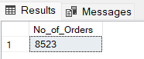

**4. AVG RATING**

select round(avg(Rating),2)

as avg_rating

from blinkit_data;

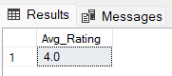

**#1: Analyze the impact of fat content on total sales.**

**SELECT `Item Fat Content`, SUM(`Total Sales`) AS Total_sales,**

**round(avg(`Total Sales`),3) as avg_Sales_million,**

**round(avg(Rating),2) as avg_rating,**

**count(*) as no_of_items**

**from blinkit_data**

**group by `Item Fat Content`**

**order by Total_Sales desc ;**

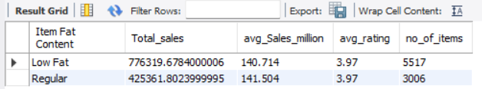

**#2. Total Sales by Item Type:**

**select `Item Type`, round(sum(`Total Sales`),2) as type_sales,**

**round(avg(`Total Sales`),3) as avg_Sales_million,**

**round(avg(Rating),2) as avg_rating,**

**count(*) as no_of_items**

**from blinkit_data**

**group by `Item Type`**

**order by type_sales desc;**

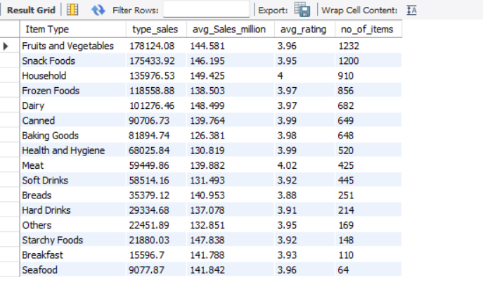

**#3: Fat Content by Outlet for Total Sales**

**select `Outlet Location Type`, `Item Fat Content`,**

**round(sum(`Total Sales`),2) as total_sales**

**from blinkit_data**

**group by `Outlet Location Type`, `Item Fat Content`**

**order by `Outlet Location Type`;**

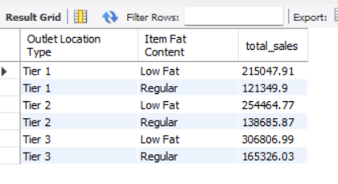

**#4: E. Total Sales by Outlet Establishment**

**SELECT `Outlet Establishment Year`, round(sum(`Total Sales`),2) as total_sales**

**FROM blinkit_data**

**GROUP BY `Outlet Establishment Year`**

**ORDER BY `Outlet Establishment Year`;**

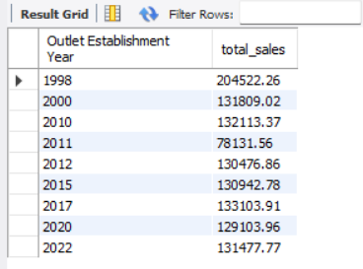

**#5: All Metrics by Outlet Type:**

**SELECT `Outlet Type`,**

**round(sum(`Total Sales`),2) as total_sales,**

**round(avg(`Total Sales`),3) as avg_Sales,**

**count(*) as no_of_items,**

**round(avg(Rating),2) as avg_rating,**

**round(AVG(`Item Visibility`),2) as `Item Visibility`**

**FROM blinkit_data**

**GROUP BY `Outlet Type`**

**ORDER BY total_sales DESC;**

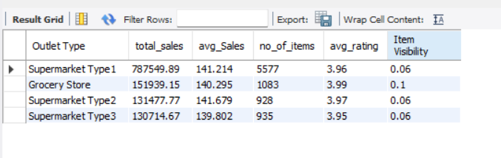

**#6: Percentage of Sales by Outlet Size**

**select `Outlet Size`, sum(`Total Sales`) as TS,**

**round(sum(`Total Sales`)*100 / sum(sum(`Total Sales`)) over(),2)as percent_sale**

**from blinkit_data**

**group by `Outlet Size`**

**order by percent_sale desc;**

